Support and locomotion in organisms
SUPPORT IN TERRESTRIAL PLANTS
Importance of support in terrestrial plants
1. Enables holding and exposing leaves to receive maximum sunlight for photosynthesis
2. Enables exposing flowers in the most suitable position for pollination
3. Allows holding fruits and seeds in the possible favorable position for dispersal
4. Maintains plant shape.

SUPPORT MECHANISMS IN TERRESTRIAL DICOTS
- Turgidity of cells
This is achieved by Turgor pressure, which is the outward pressure exerted by protoplasm onto the cell wall by a fully turgid cell.
The closely packed parenchyma cells in cortex and pith of the stem take up water by osmosis. When fully turgid, the cells press against one another, creating turgor pressure hence keep herbaceous non-woody plants and young woody plants erect. Absence / insufficient water reduces turgor pressure causing loss of support due to wilting. (FA,40)
Wilting is the shrinking of whole plant cells due to excessive loss of water by evaporation, leading to drooping of plant. As continuous evaporation occurs from exposed plant cells, water is continuously absorbed from neighboring cells by osmosis leading to shrinking of the cells. (FA,53)
- Mechanical tissues; (FA,40, BS, 172)
(a) Collenchyma cells; these are closely packed living cells, with uneven thickened cellulose cell walls. It provides support in actively growing plant parts.
(i) Collenchyma tissue provide flexible support (a mechanical function) to stems and leaves, enabling stems to withstand the lateral force of the wind.
(ii) The walls of collenchyma cells can be deformed by pressure or tension and retain the new shape even if the pressure or tension ceases, allowing growth and support in different directions.
Location: in young plants, herbaceous plants and some organs such as leaves, petioles and flowers.

(b) Sclerenchyma fibers and sclereids; these are closely packed cells with lignified cell walls and are dead when mature. These mostly provides mechanical support in areas with limited growth.
(i) The tough and elastic cell wall of elongated fibers allow the cell to be deformed but can regain their original size and shape when the pressure or tension is released.
(ii) Provides great tensile strength in plants parts, such as in the vascular tissues of stems and roots and the bundle sheath of leaves
(iii) Support the tree while the elasticity allows the trunk and the branches to bend in the wind without breaking.
Location: woody fibers are found in stems and midrib of leaves, where they provide toughness and rigidity, pith, phloem, fruit walls, seed coats, less abundant in roots except in specialized support roots.

- Vascular tissues (xylem vessels and tracheids) BS, 174)
These are dead cells with lignified and thickened cell walls.
- They provide the greatest mechanical strength to resist bending in the stem, reinforce strength in the root and are the most important supporting cells in the veins of leaves.

Vascular tissue in young dicot stems | Vascular tissue in dicot roots
Location: at the periphery (near edge)  This increases the resistance to the bending produced by wind or the passing animals.  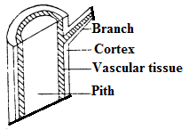 | Location: at the root center  The solid cylinder increases the strength to resist the uprooting force produced by the pulling effect of wind.  The solid cylinder also provides sufficient incompressibility against the compression by the load from the plant and against the pressure exerted by the surrounding soil  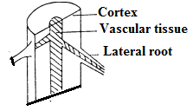
- In leaves, vascular tissue is located in the midrib and veins, and it extends throughout the leaf surface. This enables resistance against tearing of leaves blade by the force of the wind.
- In woody stems, the lignified secondary xylem tissues (wood) makes the stem very hard and rigid for extra support
Some herbaceous dicots use tendrils, thorns, clasping roots, twinning stems to attach on other plants.
Role of structure of cells of vascular tissues in support.
- Xylem parenchyma tissue; has spherical/polygonal cells; that form radial sheets/medullary rays for support; (FA 428)
- Parenchyma tissue has cells with a flexible membrane; that allow the cells to expand and become turgid; with cells closely packed; hence offering hydrostatic support;
- Collenchyma tissue; has polygonal/rectangular cells; that have cellulose cell wall; to offer tensile strength; and compressional strength; for extra support;
- Sclerenchyma tissue; in the form of fibres; is lignified; elongated; and longitudinally arranged in sheets/bundles for support;
- Stone cells/sclereids are also a form of sclerenchyma; which are also lignified; spherical; arranged in groups; to offer firmness;
- Xylem also comprises of the trachieds; and vessel elements; that are also lignified to offer strength;
- In stems vessels are at the peripheral of the stem for support;
- Trachieds have tapering ends that interlock with neighboring trachieds for firm support;
- In roots vessels run longitudinally as separate rods to resist collapsing due to tugging strains caused by bending of aerial parts;
- Mature xylem completes development by annular; or spiral; or reticulate lignification to increase support;
SUPPORT IN AQUATIC PLANTS (HYDROPHYTES)
Support due to buoyancy is provided by:
- Surrounding water, whose density is much higher than that of air, hence providing a larger up thrust support force.
- Presence of numerous large air spaces (intercellular spaces) in stems and leaves, which form air-filled cavities extending through the tissues provide buoyancy.
Note: When removed from water, most hydrophytes collapse quickly because of having poorly developed (some lack) mechanical tissues (i.e. collenchyma and sclerenchyma) and xylem tissue is reduced, since it is unnecessary (no need to transport water within the body and buoyancy is provided by water for support).
COMPARISON OF SUPPORT IN TERRESTRIAL PLANTS AND HYDROPHYTES
Terrestrial Plants | Aquatic Plants
Require mechanical support because air has low density hence will not hold plant structures in the same way water does. | Density of water is much higher than air, hence providing a larger support force, with no much need for mechanical tissues.
The presence of collenchyma cells, sclerenchyma cells and the abundant highly lignified thick-walled xylem vessels in terrestrial plants implies that support depends on these specialized thick-walled cells. | No collenchyma and sclerenchyma cells are found in aquatic plants, and the poorly developed xylem vessels indicate that aquatic plants do not depend on these cells for mechanical support.
Small air spaces in stem since air with low density only provides limited support to terrestrial plants. | There are numerous large air spaces in the stem and the leaf of aquatic plants suggest that aquatic plants depend on the buoyancy of water for support.  T.S of stem  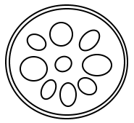  Air spaces

Locomotion in animals
LOCOMOTION AND MOVEMENT
Locomotion: The process of changing position of the entire body.
Movement: The process of displacing body parts while maintaining the whole body in one position.
THE BASIC TYPES OF MOVEMENT
Movement involves these basic mechanisms.
Mechanism | Importance of the process to organisms involved
Amoeboid movement | a) Enables amoeba to move about to (i) obtain food (ii) avoid dangers, like predators, energy e.g. heat (iii) excrete.  b) Enables white blood cells (Leucocytes) like phagocytes, macrophages of the lymph and Kupffer cells of liver to (i) engulf antigen or microbes (ii) move in the circulatory fluid.
Ciliary and flagellar movement | a) Ciliary movement enables paramecium to (i) avoid danger (ii) drive water and food into their gullet.  b) In certain molluscs Ciliary movement facilitates gaseous exchange by passing water currents over the gills  c) In echinoderms Ciliary movement enables locomotion by driving water through the water vascular system.  d) Ciliary movement by the cells lining the respiratory tract of humans drives away the microbes and dust particles in inhaled air towards the nose or mouth.  f) Ciliary movement by cells in the oviduct or fallopian tubes of human female moves ova towards the uterus.  g) Ciliary movement in nephridia of annelids e.g. earthworms move wastes  h) Flagellum of sperms enables their swimming movement towards the ova.  i) Flagellum enables the movement in certain protozoans like euglena
Muscular movement | Muscular movements enable (i) animals to find food, mates, avoid predators and unsuitable environmental conditions (ii) flow of contents in the gut and arteries (iii) positioning of eyes and external ears for effective functioning in some animals
Description of the three modes/ types of movement in organisms
AMOEBOID MOVEMENT
Definition: is a type of movement characterized by protrusion of the protoplasm by flow of cytoplasm to form temporary feet-like structures called pseudopodia.
●Several theories have been advanced about the formation of pseudopodia, but the most accepted is the sol-gel-sol transformation of the cytoplasm.
Zone of solation
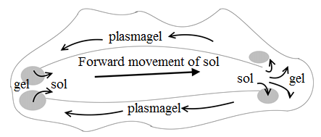
Direction of movement | Description of amoeboid movement according to the sol-gel-sol theory
Anterior  Zone of gelation | ● The plasma membrane attaches to the substratum.  The cytoplasm of the cell changes between the fluid sol (endoplasm) at the body centre and more solid gel (ectoplasm) at the body peripheral.  ● At the leading end of the pseudopodium, the fluid plasma sol is converted to solid plasma gel. The endoplasm then flows forward to form a tubular protrusion. At the rear end, the solid gel is converted into fluid sol and flows inwards.  ●The movement is sustained by contraction of the outer gel layer in the rear end which squeezes inwards, causing cytoplasmic streaming towards the tip of the pseudopodium.  ●Now the plasmagel tube contracts and the body moves forwards. Soon after this a new pseudopodium is again formed in this direction.

DESCRIPTION OF CILIARY MOVEMENT
Definition: the rhythmic beating of fine hair-like processes(cilia) projecting from the cell membrane of certain cells.
Description by diagrammatic illustration | Description in words
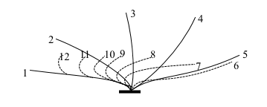 | ● This involves back and forward beating of cilia along the body of an organism. It involves the power stroke and passive recovery stroke. The power stroke is the back-ward movement while the recovery stroke is the forward movement in relation to movement of the organism.  ●During the power stroke, the fully extended cilium moves backwards more quickly, exerting maximum force on the surrounding fluid. Propelling the organism forward.  ●In the passive recovery stroke phase which follows the effective stroke, the cilium moves forward when bent, to reduce drag.
Flagellar locomotion
This involves the use of a flagella by the undulating movement (wave like movement) from the base to the tip along the length of the flagella. This exerts pressure on the surrounding fluid as the animal is pushed forward. E.g. in sperm cells, euglena.
MUSCULAR MOVEMENT
The unique properties of muscles which enable their functionality include:
(a) Ability to be Excitable (b) Ability to Contract (c) ability to be Extensible (d) Being Elastic
Muscular movement is dependent on skeletal systems.
TYPES OF SKELETONS
Hydrostatic skeleton or Hydro skeleton
Hydro skeleton is a skeleton composed of high-pressure fluid in a cavity (coelom), surrounded by muscle layers.
It’s the most widespread type of skeleton found in:
a) Organisms like annelids (e.g. earthworms), cnidarians (e.g. jellyfish, sea anemones), nematodes (e.g. round worms)
b) Structures like mammalian eyes (the aqueous and vitreous humour), spinal cord (cerebrospinal fluid), extra embryonic membranes (amniotic fluid).
The main principle on which the hydro skeleton operates is the incompressibility of water. contractions of Muscles exert pressure on the fluid to form a strong rigid skeletal unit that provides a base for movements to occur.

The minimum volume of fluid for a particular system must remain constant for effective contraction and expansion of the muscles. Too much loss of fluid causes pressure loss, and too much gain causes over swelling. These cause failure of muscle stretching and hence movement fails. This explains why snails and earthworms are restricted in their activity to moist conditions.
Advantages: ●Hydro skeleton is elastic and can bend accordingly when a muscle contracts enabling an organism to fit in narrow burrows.
Disadvantages:
● Some organisms that use a hydro skeleton regularly face a loss of pressure due to loss of body fluid.
●Due to lack of a strong supportive system, majority of the invertebrates are small, which increases surface area to water loss
●Lack of effective support to the body results into slow movements slowing the animals’ escape response from predators.
●The organisms are limited to moist habitats because of the need to minimize water loss by evaporation
Exoskeleton
Exoskeleton is a skeleton where the skeletal elements are external to the body muscles.
Exoskeletons do not grow with the body so in arthropods they must be periodically shed to allow growth.
In insects and spiders, the cuticle is waterproof due to extra deposits of Wax.
●Chitinous exoskeleton is in: arthropods like insects, arachnids (e.g. spiders) crustaceans (e.g. crabs, lobsters), some fungi and bacteria.
●Bone, cartilage, or dentine make up the exoskeletons of turtles.
Advantages
● Exoskeletons contain resistant components that offer protection against predators, bacterial attack and desiccation while on land.
●Exoskeletons contain rigid components that offer support enabling maintaining body shape.
●Exoskeleton of arthropods contains rigid framework which allow attachment of muscles.
● In arthropods the exoskeleton is modified into appendages which offer more rapid locomotion than the hydrostatic skeleton
● The arthropod exoskeleton contains modified parts for feeding and structures for respiration.
● Exoskeletons are often highly coloured for camouflage from predators, recognition by mates, and warning to scare off predators.
●The arthropod exoskeleton is jointed enabling flexibility in locomotion.
Disadvantages
● Since exoskeletons are rigid and do not grow with the body, in arthropods they disrupt smooth and steady growth and so must be periodically shed to allow growth, which makes the animal temporarily vulnerable for predation and water loss by evaporation until hardening.
● An exoskeleton cannot support large sized animals because of their large volume and body mass, that requires heavy and thick exoskeleton.

Endoskeleton
Endoskeleton is a Skelton where the skeletal elements are positioned internal to the body muscles which move it.
(i) The vertebrate endoskeleton is made up of bone and cartilage tissues.
(ii) In sponges, the endoskeleton is purely for support, but in vertebrates and echinoderms it’s also for attachment of muscle and locomotion.
(iii) Echinoderms and chordates have a true endoskeleton derived from mesodermal tissue
Found in: a) Chordates: birds, mammals, reptiles etc.
Advantages
●Vertebrates have a strong support system and as a result, they develop faster and bigger bodies than invertebrates.
● It’s jointed for flexibility to allow diverse range of locomotory patterns: swimming, digging, running, climbing, and flying, feeding (jaws).
●Endoskeleton does not limit space available for internal organs since it increases in size as organs grow and can support greater weight.
●Bone are hard for protecting delicate parts like the brain, lungs, heart, spinal cord, etc.
●Bone tissue is mineralized and hence acts as mineral reserve for the body’s’ physiological processes.
●Mammalian bones manufacture the defensive leucocytes
Disadvantages
●Endoskeletons are enclosed in other tissues do not offer much protection from predators in some animals.
● Endoskeletons do not contribute to minimizing water loss from the body by evaporation

DESCRIPTION OF HYDROSKELETON OF THE EARTHWORM
Only the structures that make up the skeleton are required, not description of the whole body.
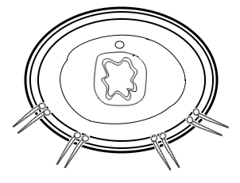
Epidermis  Longitudinal muscle muscle  Circular muscle  Coelom  Chaeta (seta)  Gut | The body of the worm is cylindrical (tubular), partitioned into many small separate, but segments, enclosed by epidermis, which is a thick wall made of two layers of muscles i.e. outer circular muscles and inner longitudinal muscles running from anterior to posterior; the inside contains a highly pressured incompressible fluid-filled cavity (coelom); each body segment bears four pairs of chaetae, except the first and last segments.  NB: segmental partitioning prevents backflow of the coelomic fluid which would provide little elongation
DESCRIPTION OF THE EARTHWORM’S LOCOMOTION
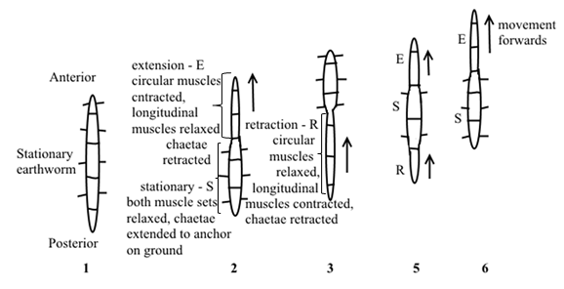

●An earthworm moves by changing the shape of its body. At one moment its long and thin, and at the next its short and thick. It also uses chaetae to attach on to the ground.
The change in the shape of the body is due to action of antagonistic muscles in its body wall.
The outer layer of the body wall has circular muscles while the inner part of the body wall has longitudinal muscles. To make the body long, the circular muscles contract as longitudinal muscles relax. To make the body short and thick, circular muscles relax as longitudinal muscles relax.
Locomotion in an earth worm is called crawling. During crawling, the lower body surface is attached to the ground using chaetae.
At the anterior end, the circular muscles contract as longitudinal muscles relax against the hydrostatic skeleton, chaetae are withdrawn from the ground, elongating the body, which is then extended forward. The longitudinal muscles at the extreme anterior end then contract as circular muscles relax, chaetae anchor the body of the earth worm to the ground, pulling the hind body part. This wave of peristaltic contraction and relaxation towards the posterior body causes locomotion of an earth worm.

LOCOMOTION WITH AN EXOSKELETON
Arthropods like insects locomote by walking and flying.
Attachment of insect muscles
Insects have indirect and direct flight muscles.
Indirect flight muscles are attached to the walls (exoskeleton) of the thorax and not to the wings. There are two sets of antagonistic indirect flight muscles i.e. dorsoventral muscles attached from the roof of the thoracic cuticle (tergum) to the floor of the thoracic segment (sternum). And a pair of longitudinal muscles.
Attachment of wings
The base of the wing attaches to walls of the roof of the thorax (tergum)
ACTION OF INDIRECT FLIGHT MUSCLES e.g. houseflies, bees and wasps, etc.
Upstroke (wings raised / elevated) | Down stroke (wings lowered / depressed)
Wing raised  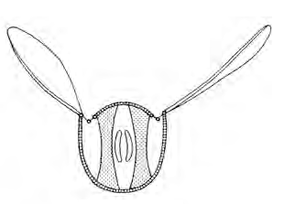  Tergum less arched  Dorso-ventral  contracted  Sternum  Longitudinal muscle  relaxed | Longitudinal muscle  contracted  Sternum  Dorso-ventral  relaxed  Tergum more arched  Wing lowered  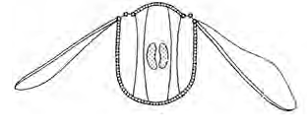
To raise the wing, the dorsoventral muscles contract, longitudinal muscles relax, the tergum (roof of the thorax) is pulled downwards, wings are raise.
To lower the wings, longitudinal muscles contract, dorsoventral muscles relax, the tergum raises upwards, wings are moved downwards.
Attachment of direct flight muscles
These are muscles which directly attach to the base of the wings e.g. dragon flies, mayflies, butterflies and grasshoppers.
Action of direct flight muscles
Lowering of the wing:
● During the upstroke, the elevator muscles contract, the depressor muscles relax, the wings are elevated.
Raising of the wing
● During the downstroke, the depressor muscles contract, the elevator muscles relax at the same time, the wings are depressed down.
Wing raised
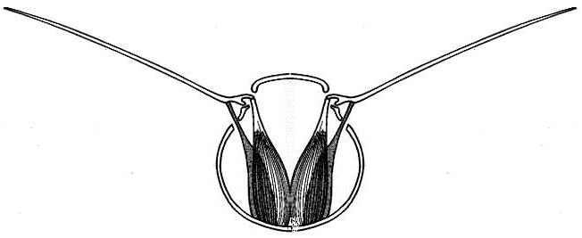
Depressor relaxed
Elevator contracted
Tergum
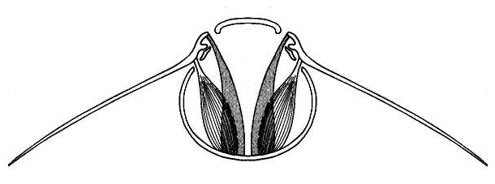
Sternum
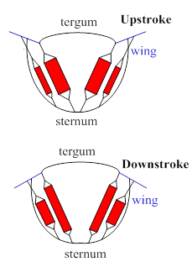 | 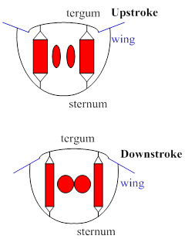

COMPARISON OF DIRECT AND INDIRECT FLIGHT MUSCLES
Direct muscles | Indirect muscles
1. Directly attach to wing bases e.g. dragon flies, mayflies  2. Wing beat is slower | 1. Attach to interior of thorax (NOT directly to wings) e.g. houseflies, honey bees, etc  2. Wing beat is higher

DESCRIPTION OF WALKING IN INSECTS
●Walking is achieved by the coordinated activity of 6 legs all attached on the thorax.
●A limb bends (folds) by contraction of flexor muscle and relaxation of extensor muscle simultaneously (at the same time).
●A limb straightens (extends) by contraction of extensor muscle and relaxation of flexor muscle simultaneously.
●When the insect starts to walk, the 2nd leg on one side and the 1st and 3rd legs on the other side support the body off the ground while the other 3 move forward.
●The 1st leg on the side where the 2nd leg is stationary pulls the insect, while the 3rd leg of the same side and the 2nd leg on the other side push.
●The process is then repeated but with the role of each three of limbs reversed.
ENDOSKELETON
This is a skeleton where the skeletal elements are located internal to the muscles attached to them.
The vertebrate skeletal tissue is composed either of cartilage only like in elasmobranch fishes e.g. dogfish and sharks or both cartilage and bone covered by a muscular system.
LOCOMOTION IN FISH
Most fish have a line of muscle blocks, called myotomes, along each side of the vertebral column.
To swim, the muscles alternately contract on one side and relax the other side in a coordinated wave of contraction from the head to the tail. This creates a forward force with resistance from the surrounding water to push the fish forward.
They also use their fins to propel themselves through the water in this swimming motion.
The lashing action of the tail produces different forces like;
The thrust force; resulting from the pushing action of the tail fin against the water.
SUPPORT (BUOYANCY) IN FISH
Elasmobranchs like dog fish sharks, skates and rays. | Teleost like Nile perch
●Support is provided by constant swimming using fins to avoid sinking.  ●How they are adapted to this: (1) possession of large pectoral and pelvic fins which direct swimming upwards (2) possession of heterocercal tail i.e. a tail with smaller upper and larger lower lobes for generating much lift and forward motion  ●During forward motion the pectoral and pelvic fins, generate a force which provides support. | ●Support is provided by adjusting air in the swim bladder. During upward movement, the swim bladder is gradually filled with air to reduce its density.  NB: Unlike in elasmobranchs, the teleost’s pectoral fins are only moved at will e.g. during braking and steering but do not act as main support structures.

INSTABILITY IN FISH
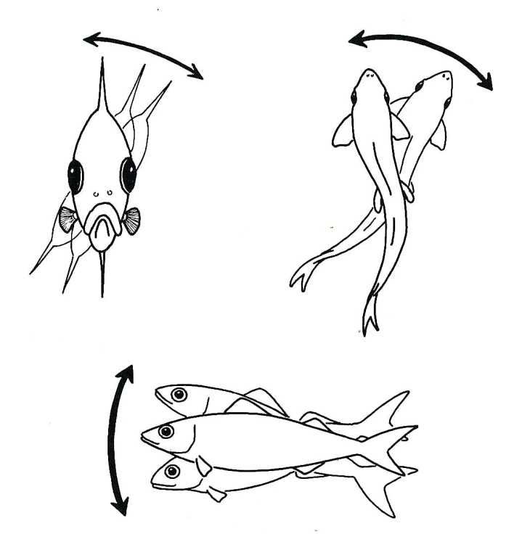
Pitching
Rolling
Yawing
Rolling: rotation of the body about its longitudinal axis. It’s counteracted by dorsal, ventral (vertical) and pectoral (horizontal) fins acting like stabilizers.

Pitching: tendency of the fish’s anterior end to plunge vertically downwards. It’s counteracted by (i) pectoral fins and pelvic fins (ii) dorsal-ventral flattening of the body in the dogfish.

Yawing: lateral side to side deflection of the anterior part of body resulting from the propulsive action of the tail (vertical axis rotation). It’s counteracted by (i) general massiveness of anterior part of body (ii) water’s pressure against the side of the body (iii) action of median, dorsal, anal, ventral fins (iv) lateral flattening (compression) of the body

ADAPTATIONS FOR LOCOMOTION IN FISH
●Fish’s body is streamlined to reduce water resistance during swimming
●The slippery layer of mucus on the skin reduces water resistance during swimming
●The presence of many fins enables the fish to swim and also maintain its balance / stability in water
●The lateral line enables sensitivity of fish and also functions as an echo location process for the fish to identify its surroundings while in water
●Scales are arranged in a head to tail direction to reduce water resistance during swimming
●The swim bladder in bony fish maintains buoyancy
●Extensive blood vascular system supplies oxygen and nutrients to the muscle tissues for contraction and drain away wastes
●Body is highly muscular to generate great propulsive force against water resistance
●The neuromuscular activity is highly coordinated for proper movement.

LOCOMOTION IN BIRDS
EXTERNAL AND INTERNAL FEATURES THAT ADAPT BIRDS TO LOCOMOTION
●Body of Birds is streamlined reducing air resistance during flight.
●The bird has hollow bones to reduce weight, and many unnecessary bones are fused into a single structure e.g. some vertebrae, pelvic girdle, finger and leg bones.
●Many unnecessary parts like urinary bladder and pinna are eliminated while reproductive organs (testes, ovaries and oviducts) are kept tiny during non-breeding seasons to reduce weight.
●The sternum bone is extended into a large keel, for the attachment of large powerful flight muscles.
●The vanes of the feathers have interlocking barbules that zip them together, giving the feathers the strength needed for flight.
●The major wing bones have internal reinforcements to prevent bending during stress.
●The respiratory system is extensive and efficient in supplying muscles with oxygen to facilitate much energy release needed in muscle contraction during respiration.
●Their efficient circulatory system powered by a four-chambered heart enables fast supply of oxygen and food to the body tissues and carry away wastes.
●The large brains that are connected to eyes coupled with high-speed nerve transmission enable quick decision making especially when landing.
●The large size of eyes in relation to their body size, coupled with eye keenness enable high visual acuity without crashing into objects.
●The flight muscles of most birds contain oxygen-carrying compounds, (myoglobin and cytochrome) for storing much oxygen which facilitates the release of much energy needed in muscle contraction.
●The forelimbs have become modified into wings which act as aero foil, generating lift when passed into air.
●They have high body temperature which maintains the high metabolic rate for generating much energy.
● They can fold the legs during flight to reduce friction.
FLIGHT BIOMECHANICS (FLIGHT BIOPHYSICS)
THE BIRD’S WING AS AN AEROFOIL / AIRFOIL
Aero foil / Airfoil: A structure whose shape and relative position provides a higher lift force, propulsion, and stability in a flying object.
PRINCIPLES OF THE AEROFOIL
The four basic forces at work when a bird is in flight are: Lift, Thrust, Gravity (weight) and Drag of which only gravity is constant (unchanging), the remaining three forces can be altered.
NB: Weight is a body force, not an aerodynamic force.
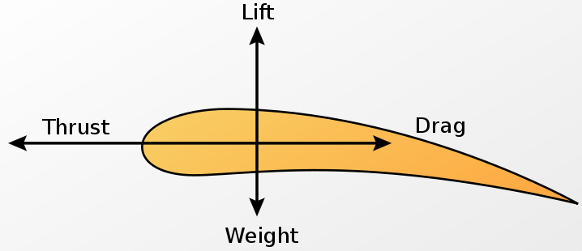

In a bird flying at a constant speed, all four of these forces are in balance or equilibrium.
Weight: a continuous downward force (force of gravity) that flying objects must constantly overcome to stay in the air. The opposing force of gravity is lift.
Thrust: the force generated by flapping action of wings which moves the bird forward and opposes drag. To move forward the flying bird must overcome drag. Drag can be reduced by streamlined shapes.
Drag (air resistance): is the friction between the moving object and the air, opposing thrust. The more streamlined or aerodynamic an object is, the less air resistance the object generates.
Drag is higher when
(i) The surface area of the object exposed to the fluid flow is higher (the reason why birds spread out their wings to slow down or land)
(ii) The object is moving faster (or the relative fluid flow is faster)
(iii) The fluid has more momentum, or inertia (high fluid viscosity and density e.g. at low altitudes)
Note that air at lower altitudes has more oxygen to facilitate muscle contraction of wings but is thicker and therefore increases drag.
Lift: the mechanical aerodynamic force generated by the wings which directly opposes the (gravity) weight of
a bird. Lift is higher when
(i) The area of the bottom of the wing is larger
BERNOULLI’S PRINCIPLE AND AEROFOIL OPERATION
Daniel Bernoulli’s theorem: an increase in the speed of a fluid produces a decrease in pressure and a decrease in the speed produces an increase in pressure.
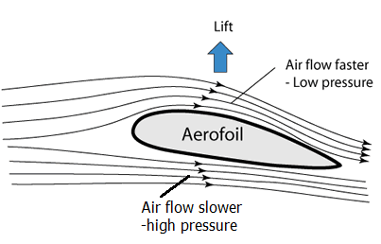

As the bird flies, the air splitting at the front of the wing must rejoin at the back of the wing. The curved top surface, makes air to move faster across the top than the bottom. Faster moving fluids create less pressure, so the bottom of the wing creates greater pressure than the pressure exerted downward above the wing, resulting in a net upward force, or lift.
The faster air moves across the wing the more lift the wing will produce, flapping therefore increases this airflow and thus increases lift. The bird doesn’t propel air underneath its wing; instead it cuts into the air with the leading edge to obtain the flow over the surface that it requires.
EFFECT OF ANGLE OF ATTACK ON LIFT
The angle of attack (AoA), is the angle at which the leading edge of wing cuts into the airflow.
NB: It’s the angle of the wing relative to airflow.
●Increasing the angle of attack increases the volume of air diverted over the wing and leads to an increase in lift, but this is at the expense of drag which quickly increases.
●In a bird excessive AoA results in air turbulence / interruption of airflow above the wing which causes a flight stall e.g., when taking off or landing.
● Air turbulence above the wing in birds is prevented by (1) the alula (bastard wings) and (2) end-feathers, both of which serve as sloths to smoothen the airflow above the wings. The alula is formed by 3 or 4 feathers attached to the first digit. NB: Angle of attack decreases with increasing speed.
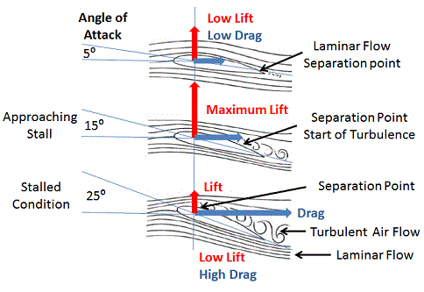

MECHANISM OF FLAPPING FLIGHT
Attachment of flight muscles in a bird’s thoracic region
5 Whole body lifted
4 Upthrust transmitted from wing to coracoid
3 Air resistance gives upthrust on wing
2 Wing pulled down
1 Major pectoral muscle contracts
Tendon of minor pectoral muscle
Coracoid
Minor pectoral muscle
Major pectoral muscle
Sternum
Keel
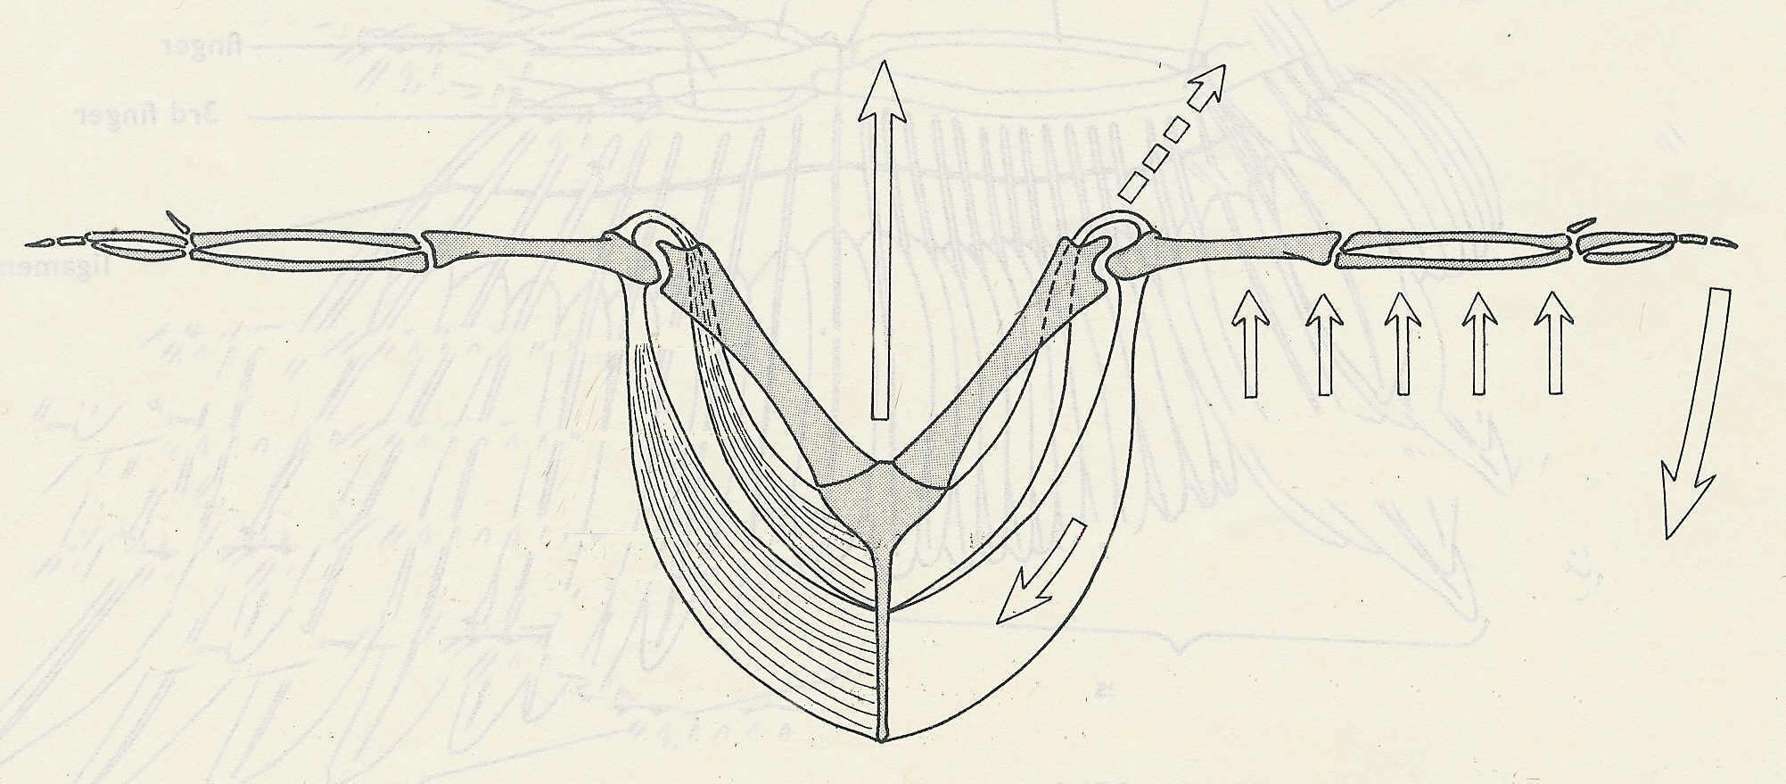

Downstroke  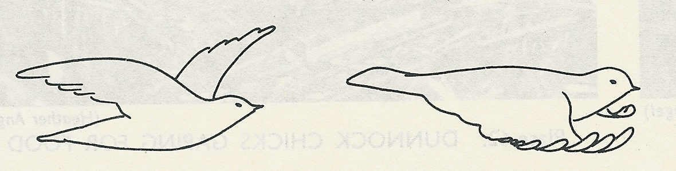  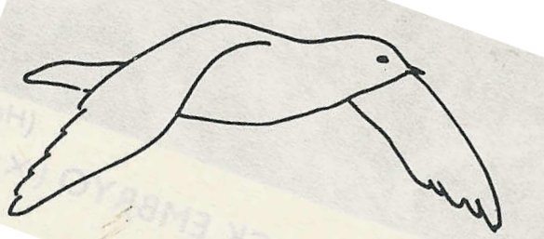  1, 2 and 3 are successive stages of down stroke.  3 | ●Downstroke is caused by contraction of pectoralis major muscle and relaxation of pectoralis minor muscle at the same time;  2  1
Upstroke: Flexed wrist reduces air resistance.  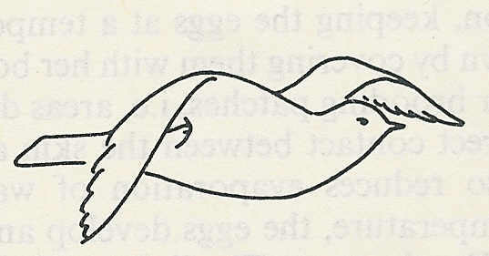 | The up-stroke of the wing is much more rapid than the down-stroke.  ●During upstroke the pectoralis minor muscle contract; the pectoralis major muscles relax at same time; the wings are lifted.

Why does the slower moving air generate more pressure on the wing than the faster moving air?
In calm air, the molecules are moving randomly in all directions. However, when air begins to move, most (but not all) molecules are moving in the same direction. The faster the air moves, the greater the number of air molecules moving in the same direction. So, air moving a bit slower will have more molecules moving in other directions. In the case of a wing, because air under the wing is moving a bit slower than air over the wing, more air molecules will be striking the bottom of the wing than will be striking the top of the wing.
QUESTIONS TO EXPLORE
(a) Compare gliding and flapping flights
(b) Compare the flight mechanism of insects and birds

MUSCULAR TISSUE
Muscular tissue is derived from the mesoderm and is specialized for contraction. It is made up of contractile units called muscle fibers.
TYPES OF MUSCLE
●Smooth (Involuntary / visceral) muscle;
Location: walls of blood vessels; ciliary muscle; erector-pili muscle; gastrointestinal, urinogenital and respiratory tracts. They are non-striated. Involuntary muscles are innervated by nerves of the autonomic nervous system.
●Skeletal (voluntary) muscle;
Location: attached to bones; abdominal wall; diaphragm; rectus muscle; under skin; middle ear.
●Cardiac (heart) muscle; Location: found in the heart only.
Voluntary muscles are innervated by motor nerves of the central nervous system.
Skeletal muscles
These consist of elongated multi nucleated cells called fibers. The nuclei are arranged at the periphery within the sarcoplasm (cytoplasm), enclosed by the sarcolemma (surface membrane).
Inside the muscle fibers, are thin elongated structures called myofibrils, which run along their length. The whole muscle is bound by a connective tissue.
The myofibrils have numerous small myofilaments, which are actin and myosin filaments. The arrangement of these filaments cause striations within a muscle fiber.
●The sarcoplasm contains numerous Golgi apparatus, many mitochondria, ribosomes, sarcoplasmic reticulum (endoplasmic reticulum), glycogen, lipid droplets, and myoglobin.
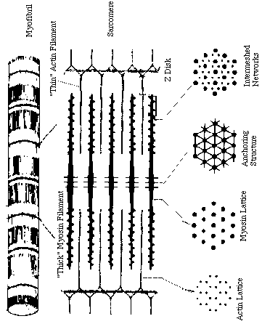
Details of myofibril (fine structure)
● A single myofibril is made of two filamentous proteins; myosin (thick) and actin (thin) overlapping to give the striated appearance.
● The striations, have the light region and the dark region i.e. light (isotropic) and dark (anisotropic) bands.

● Actin filaments are anchored at their midpoints to a structure called the Z-line.

●The region from one z-line to the next is called a sarcomere, which is the functional unit of a muscle.
NOTE: Sarcomeres are sections of myofibril that are separated from each other by areas of dense material called "Z discs".
● "A band" is the relatively darker area within the sarcomere that extends along the total length of the thick filaments.
●"H zone" is the region in which there are only thick filaments, and no thin filaments, it is at the center of the A band of each sarcomere.
The "I band" is the region between adjacent A bands, in which there are only thin filaments, and no thick filaments.
(Each I band extends across two adjacent sarcomeres)
MECHANISM OF MUSCLE CONTRACTION AND RELAXATION
When the muscle is relaxed, the tropomyosin protein molecules on the actin filaments cover the myosin binding sites, preventing myosin head from binding to actin. In presence of calcium ions, they attach onto troponin molecules and displace tropomyosin, exposing the myosin binding heads to form cross bridges for contraction to occur.
The sliding filament theory / Ratchet mechanism is used to describe the mechanism of skeletal muscle contraction.
Arrival of an action potential at the neuromuscular junction causes depolarization of the sarcolemma, creating an action potential in the sarcolemma that spreads through the transverse tubules (T-tubules), causing the sarcoplasmic reticulum to release Ca2+ into the sarcoplasm.
●Ca2+ bind to a protein troponin of actin to cause changes in troponin-tropomyosin complex that expose the myosin binding site on the actin filament.
●Calcium ions also cause hydrolysis of ATP by ATPase to release energy for contraction.
●The myosin head binds to actin forming a cross-bridge between the thick and thin filaments, using ATP energy.
● The actin filaments are then pulled and slide over the myosin filaments, creating tension and contraction of a muscle unit.
Relaxation
● Ca2+ detach from troponin-tropomyosin complex and are actively pumped back into sarcoplasmic reticulum.
●Again ATP binds to myosin head, detaching it from actin.
●Troponin-tropomyosin inhibition of actin and myosin interaction is restored, actin slide back to normal position.
● Finally, active tension disappears and the muscle length is restored. This completes the contraction-relaxation cycle.
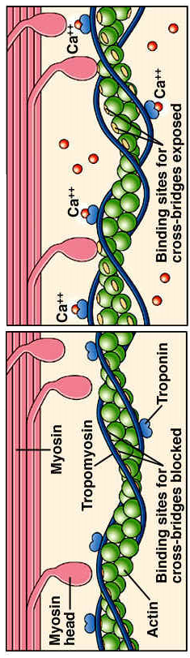
EVIDENCE OF SLIDING FILAMENT THEORY IN A CONTRACTING MUSCLE FIBRE
● Each sarcomere shortens / Z lines come closer
●I Band shortens
●H zone shortens greatly (usually disappears).
●A Band remains unchanged in length during contraction or relaxation
●Cross bridges are visible between actin and myosin in photomicrographs.
MUSCLE STIMULATION FREQUENCY AND THE LENGTH-TENSION RELATIONSHIP
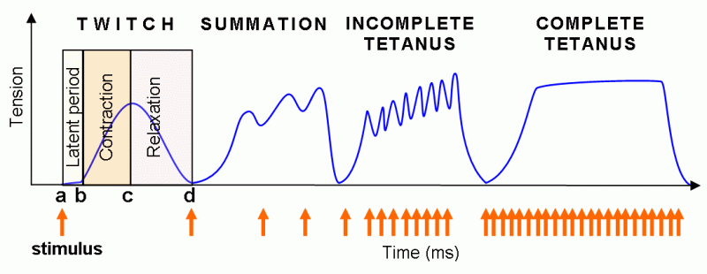

MUSCLE TWITCH
This is the rapid muscle contraction in response to a single stimulation.

LATENT PERIOD
This is a short period of delay between stimulus application and onset of muscle fiber contraction. This delay may be due to translation of the electrical response into a contraction.

ALL-OR-NOTHING LAW OF THE MUSCLE
The response of a single muscle fiber is independent of the intensity of the stimulus, provided the stimulus is of threshold strength. If the strength of the impulse is below a threshold, no contraction occurs, if the impulse is above the threshold, same contraction is given however high the intensity of the impulse increase.
THRESHOLD
This is the minimum electrical potential at which an action potential is triggered.
SUMMATION
The condition whereby two successive stimulation of a muscle before full relaxation results in fusion of twitches added together to produce a smooth contraction.
TETANUS
● The condition whereby numerous successive high frequency stimulation before full relaxation of a muscle causes a smooth, sustained maximum contraction. If the frequency of the next successive stimulus is lower than the previous, the contractions are not smooth but appear briefly separated.
NB: The ability of a muscle to undergo tetanus depends upon its refractory period.
REFRACTORY PERIOD
●A short period of in excitability in a muscle cell following stimulation.
●The amount of time it takes for an excitable membrane to be ready for a second stimulus once it returns to its resting state following excitation.
MUSCLE FATIGUE
A tetanic contraction cannot goon indefinitely. Fatigue is when muscle response gradually declines and then disappears due to continued stimulation.
Muscle fatigue results when there is tissue oxygen deprivation, exhaustion of transmitter substance, glycogen or Phosphocreatine depletion, and increased level of blood and muscle lactic acid in an exercised muscle.
SLOW-TWITCH AND FAST-TWITCH MUSCLE FIBRES
A muscle twitch is a sharp/rapid contraction of a muscle upon a single excitation.
Slow-twitch fibers;
These are muscles which contract slowly, over a longer period hence suited for steady contraction over a long period of time e.g. marathon running.
Adaptations:
(i) They have large reservoir of myoglobin for storage of oxygen which facilitate aerobic respiration to avoid accumulation of lactic acid which would make them less effective.
(ii) Have much glycogen to provide a source of metabolic energy.
(iii) Have a rich supply of blood vessels to deliver oxygen and glucose needed in aerobic respiration to provide ATP.
(iv) They have numerous mitochondria to produce ATP that maintains muscle contraction.
(v) They heavily respire fats aerobically for energy.
Reasons for respiring fat (1) to provide much ATP energy required for continued contraction over along period of time.
Fast-twitch fibers – e.g. biceps muscle
These are muscle which contract more rapidly, more powerfully, only for a short period hence suited for sudden rapid exercise e.g. weight lifting.
Adaptations:
(i) Thicker and more numerous myosin filaments.
(ii) High concentration of enzymes involved in anaerobic respiration.
(iii) Store of phosphocreatine, a molecule that can rapidly generate ATP from ADP in anaerobic conditions and so provide energy for muscle contraction.

HOW SKELETAL MUSCLE STRUCTURE RELATES TO FUNCTIONING
●Each muscle cell is long to allow considerable contractile effect.
●The fibres are parallel to each other so that contractile effect is transmitted along same axis.
●Muscle fibres taper at both ends to improve muscle strength.
●Muscle fibres have very many mitochondria to provide much ATP needed in muscle contraction.
●Cross bridges enable actin and myosin to fit into each other to allow sliding during muscle contraction.
●There is a rich supply of blood vessels to supply nutrients to and drain wastes away from cells.
●There is much myoglobin for storage of oxygen needed very much in aerobic respiration during exercising.
●There are motor end plates to allow innervation that result in contraction.
●There is a dense network of internal membrane system (including transverse tubules) for calcium ion storage which is very much needed in muscle contraction.
WHAT IS RIGOR MORTIS?
●The progressive stiffening of the body that occurs several hours after death as a result of failure of contracted muscles to relax.
WHAT CAUSES RIGOR MORTIS?
●Upon death, most muscles contract, due do presence of ATP, which allows cross bridge formation and release of calcium form the sarcoplasmic reticulum.
●However, efflux of Ca2+ from the sarcoplasm into the sarcoplasmic reticulum fails because of lack of ATP since respiration would have ceased, the myosin heads cannot also detach from the actin filaments in absence of ATP. This causes the muscle to remain contracted, relaxing only when decomposition starts.
WHAT IS THE OXYGEN DEBT?
The amount of extra oxygen required by muscle tissue to oxidize lactic acid and replenish depleted ATP and phosphocreatine following vigorous exercise.
Oxygen uptake at rest, in heavy exercise and in recovery

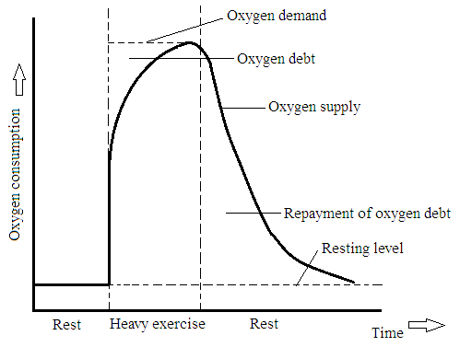

BIPEDALISM [LOCOMOTION USING 2 REAR LEGS]
Bipedal locomotion is walking, running, and standing on two rear limbs.
This requires well developed muscles and skeletal elements, operating various joints to cause movement and support body weight. The pelvis in bipedal is greatly developed to support body weight.
Walking is a rhythmic change in balance of tension in the muscles.
WHY MAN STANDS ON SOLES BUT GENERALLY SPRINTS ON TOES
●Standing on soles increases the surface area for supporting the body weight in a balanced posture.
●Sprinting on toes increases the effective length of limbs; enabling taking longer strides that propel the body forward over a greater distance and at a faster pace even if the speed of limb movement remains the same.
WHY SPRINTERS CROUCH (BEND DOWN) BEFORE TAKEOFF
Crouching creates a small angle between the ground and the main axis of the limb; resulting in maximum forward thrust rather than upward lift; hence propelling the body a greater distance forward.
QUADRUPEDALISM [PROPULSION USING FOUR LEGS]
Quadruped is an animal especially a mammal, having four limbs all specialized for walking, except humans and the birds.
●During walking, only one limb is raised at a time; the other three remain anchored to the ground to provide tripod support / stability in a sequence of leg movement as follows: left forelimb; right hindlimb; right forelimb; left hindlimb
●During slow running, tripod support is lost because the two forelimbs are moved together followed by the two hind limbs in the sequence of: left forelimb; right forelimb; right hindlimb; left hindlimb.
● During maximum speed running, a dog uses its back to attain speed. All the four legs may be lifted off the ground at the same time, full extension of the vertebral column coupled with full extension of front legs forward and rear legs rearward to increase stride length.
PLANTIGRADE, DIGITIGRADE AND UNGULIGRADE LOCOMOTION
●Plantigrade locomotion: walking with the sole of the foot flat on the ground e.g. humans, bears, rabbits, kangaroo, mice, pandas, rats and hedgehogs.
●Digitigrade locomotion: walking on the toes e.g. dog, coyote, cat, lion, cheetah
●Unguligrade locomotion: walking on the nail or nails of the toes (the hoof) with the heel/wrist and the digits permanently raised. Ungulates include horse, zebra, donkey, cattle
Advantage of a plantigrade foot: because of a large surface area, it offers stability and able to bear much weight.
Disadvantage of a plantigrade foot: locomotion is slow because of many bones and joints in the foot making the leg heavier at the far end.
Advantage of digitigrades: They are generally faster and quieter than other types of animals
QUESTION: Explain why in terrestrial tetrapods it is advantageous to have limbs below and parallel to the sides of the body e.g. in mammals rather than lateral to the body e.g. in amphibians

